Module 2: Assignment

- Give two examples of the where a frequentist notion of probability accurately describes the situation . How would you determine these probabilities?

- Give two examples of “subjective” probabilities. How would you determine these probabilities?

- An expert indicates the following probabilities:

- Probability of next summer being hotter than this summer is 0.7.
- If next summer is hotter than this one, then the probability that there will be more hurricanes next summer is 0.9.
- The probability that next summer is as hot or cooler than this summer and there are as many or fewer hurricanes is 0.2

- What is the probability that next summer will be as hot as or cooler than this summer?
- What is the probability that next summer will be hotter than this summer AND that there will be more hurricanes next summer.
- Prepare a contingency table for this question.
- What is the probability that there will be as many or fewer hurricanes next summer if temperatures are as hot as or cooler than this summer?
- What is the probability that there will be more hurricanes next summer?
- Next year, more hurricanes are observed. What is the probability that the temperatures were actually as hot as or cooler than the previous summer?
- Classify the following random variables as continuous or discrete.
- The number of cars that pass through an intersection within one minute.
- The amount of time an employee is late to work.
- The percent of people who contract the flu in February.
- The value which appears when a contestant spins the wheel on Wheel of Fortune.
- The rate (in errors per page) at which a court reporter makes a transcription error.

- Consider the following experiment to determine the value of a random variable. First roll a fair six-sided die. If the result is even, the experiment ends. If the result is odd, flip a coin twice. The random variable is the number of heads observed in a trial of the experiment. Note that if the coin is not flipped, zero heads are observed in the trial.

- What are the possible values of the random variable?
- Determine the probabilities of observing each of the possible values in (a). Then sketch the probability mass function and the cumulative distribution function.

- Examine the labeled cumulative distribution function for random variable, W, below. Determine the following probabilities:

  - The probability that W is at most 40.
  - The probability that W is at least 55.
  - The probability that W is between 40 and 60.
  - The probability that W is either less than 5 or greater than 95.

Question 6
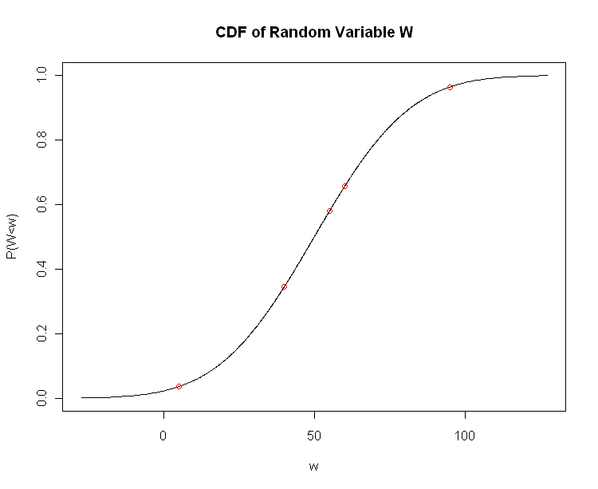
(5,0.036)
(40,0.345)
(55,0.579)
(60,0.655)
(95,0.964)

- In fact, the random variable in Question 6 has a normal distribution with mean = 50 and standard deviation = 25. On the probability density functions on the next page, sketch the probabilities indicated in Question 6.

Question 7
